Justhealth Iteration 1 Plan

# Aims:

* To have a fully functioning database with a web login screen
* The ability for users to be able to register and log in
* The login screen does not allow any erroneous data or attacks
* A 5 times failed login where the user will have to reset their password
* Password linked in with Google authenticator

# Requirements:

## 2.1 Functional requirements:

* Ability to register an account
* Ability log in to that registered account
* Ability to reset password
* A user will be locked out after 5 failed attempts

## 2.2 Non-functional requirements:

* Accessibility
* User Documentation
* Security
  + 2 Factor Authentication (Google Authenticator)
  + Encryption of passwords and sensitive user information
  + In-line network security
  + Physical network security
* Robustness
  + Error handling
  + Security (as above)
  + Eliminate the possibility of SQL injection type attacks
* Ease of Use
  + Simple and intuitive design
  + Clear colour scheme

## 2.3 Domain Requirements:

* Security
  + Legal requirements will mean that the sensitive information e.g. password will need to be encrypted.

# 3.0 Design

## 3.1 Login screen design and registration page

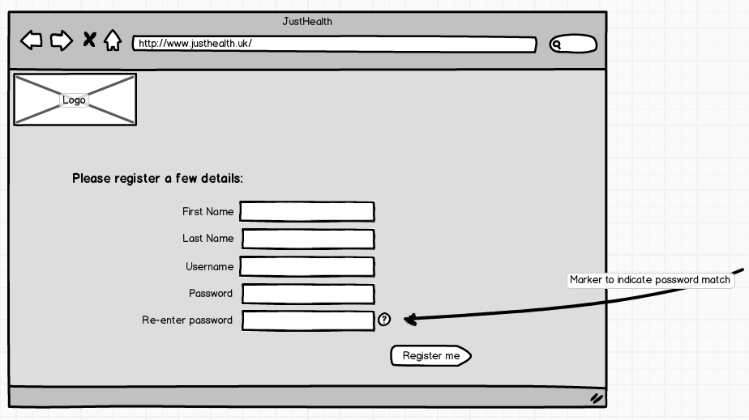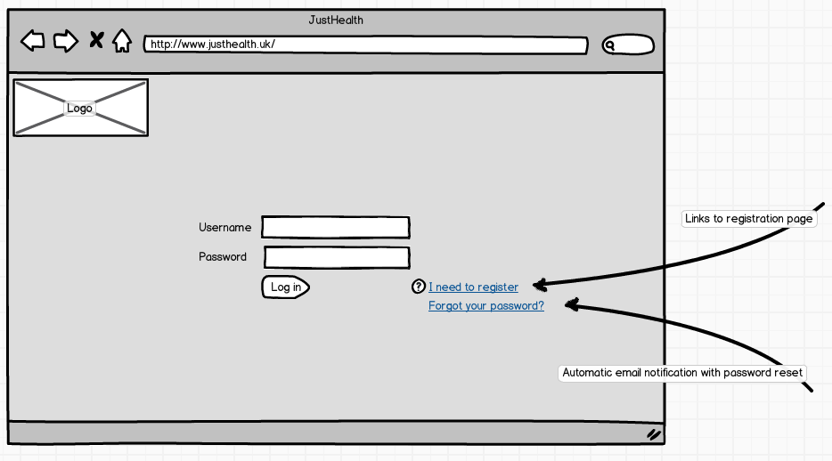

# 4.0 Testing:

## 4.1 Test cases (steve)

# 5.0 Usecase:

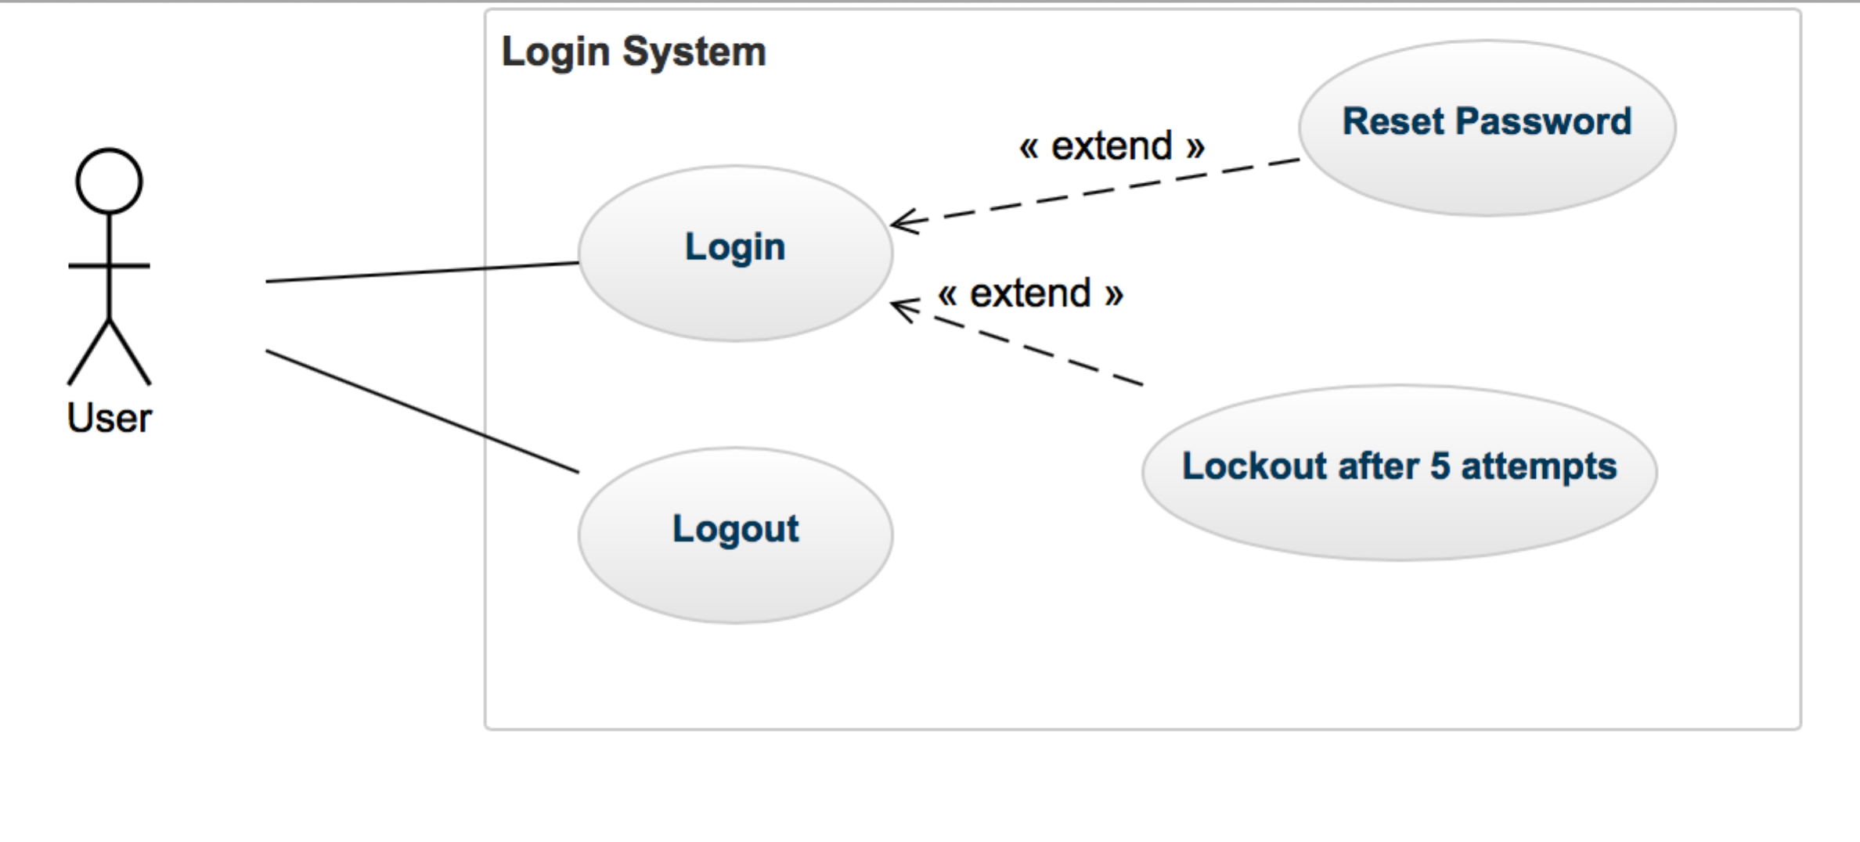

# 6.0 Database design: (Rich)

## 6.1 Entity relationship diagram

## 6.2 Conceptual Data Model

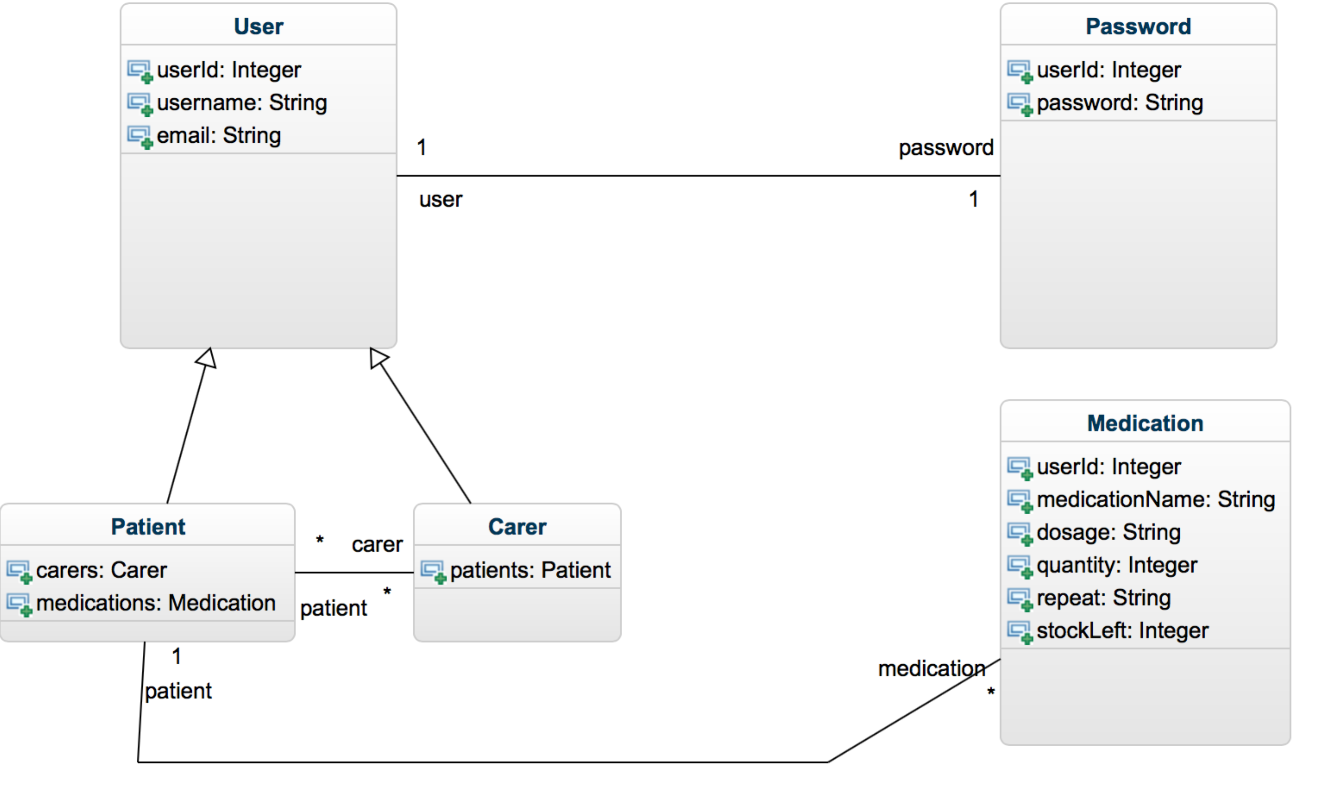

## 6.3 Logical Data Model

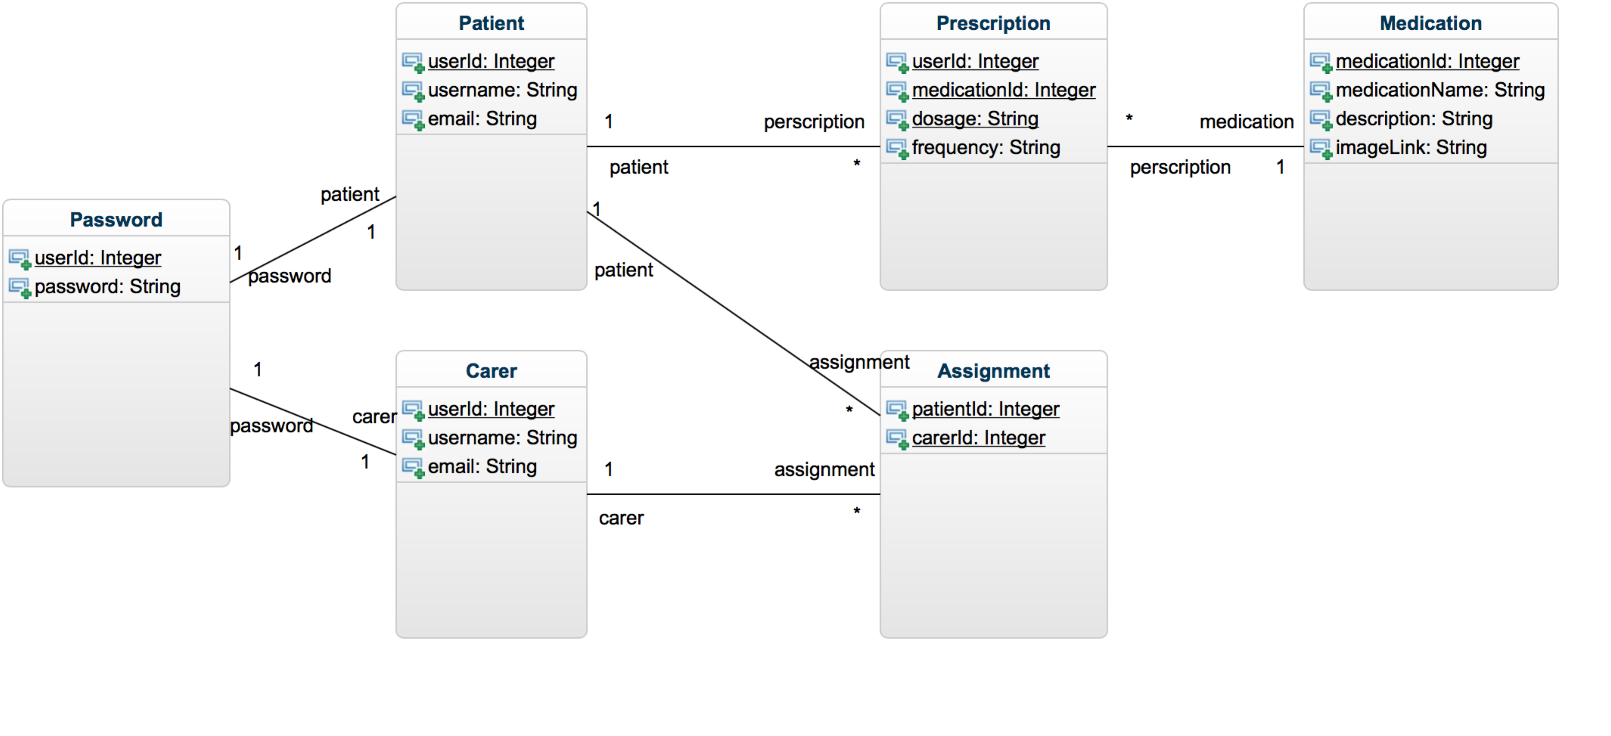

## 6.4 Physical Data Model